

**Agent Studio User Guide v2 (external)**

**July 2025**

**Table of Content**

1. Cloudera Agentic AI Workflow: Story build up
2. High Level Architecture - Agent Studio Use-case 1: Insurance
3. Lab Setup and Steps - Let’s Start!!
4. Let’s run the workflow
5. **Cloudera Agentic AI Workflow: Story build up**

I recently stepped into a new chapter as an **Insurance Advisor** - not just with one, but two major players in the industry: **Star Health Insurance** and **ICICI Lombard**.

At our last team sync, my manager dropped a mission-critical task on my plate:

“Reach out to all your customers and **recommend insurance upgrades tailored to their profiles**.”

Now let me tell you - this wasn’t just a casual outreach job.  
I’m talking to hundreds **of customers**. Each one with their own policies, risk levels, family situations, cities, payment methods - you name it.

I was like, "*Cool... so you want me to manually read through hundreds of profiles and come up with personalized insurance advice*?!"  
That’s when it hit me: this is exactly the kind of chaos AI was made for.

So I rolled up my sleeves and got to work and stumbled onto something game-changing:

An **Agentic AI Workflow**, built on **ClouderaAI**

1. **High Level Architecture - Agent Studio Use-case 1: Insurance**

**An Agentic AI Workflow, built on ClouderaAI.**

With a bit of tooling and some logic, built an intelligent pipeline that could:

🔍 **Pull real-time customer data** securely from Hive on Cloudera

📊 **Analyze policy holdings** across **both Star Health and ICICI**

🤖 **Match customers to relevant upgrades** based on their unique profile and risk factors

📬 **Deliver personalized recommendations**—automatically, at scale

🔐 **Protect sensitive data** by design (no access to credit card details, ever)

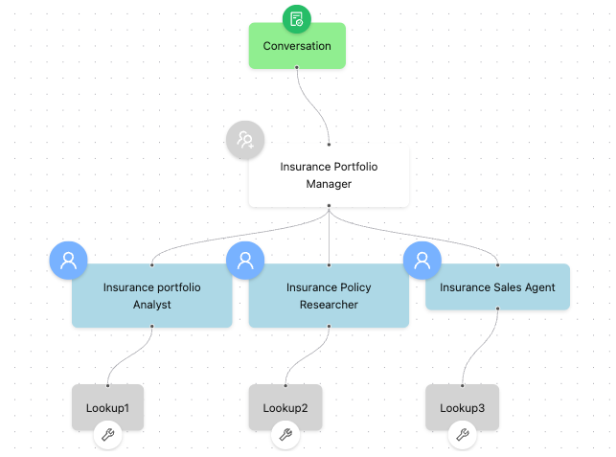

1. **Lab Setup and Steps - Let’s Start!!**

**Note:** Environment and Credentials will be shared by the Presenter.

**Step 1: Log in to Cloudera Platform & browse through Agent Studio UI**

1. Log in using the credentials provided. **Please use an Incognito window**.

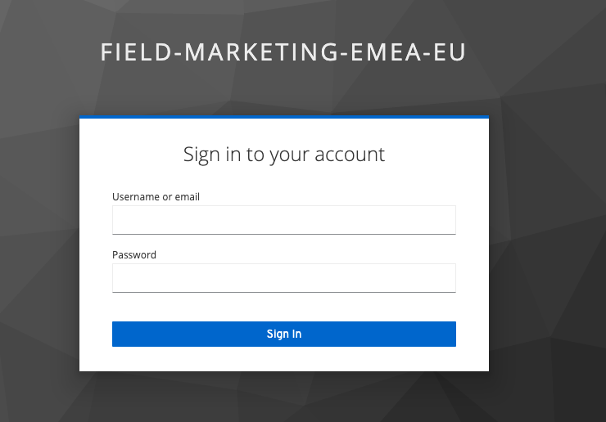

1. Select Cloudera AI

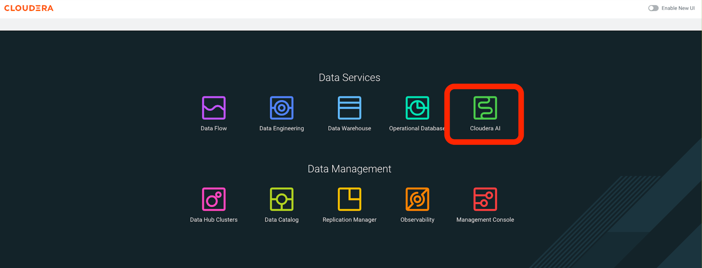

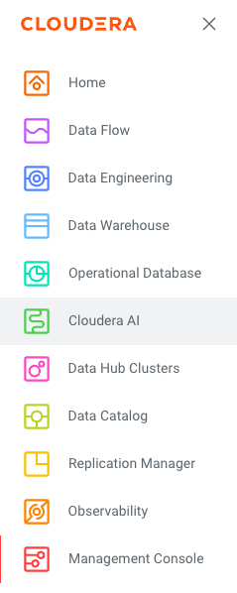

1. Click on **Workbench >** Select agentic-ai-hol-userxx-xx (example: user01-01 workbench.

**Note**: Please use this table to select the right workbench

| **User** | **Workbench** |
| --- | --- |
| User001-010 | agentic-ai-hol-user01-10 |
| User011-020 | agentic-ai-hol-user11-20 |
| User021-030 | agentic-ai-hol-user21-30 |
| User031-040 | agentic-ai-hol-user31-40 |

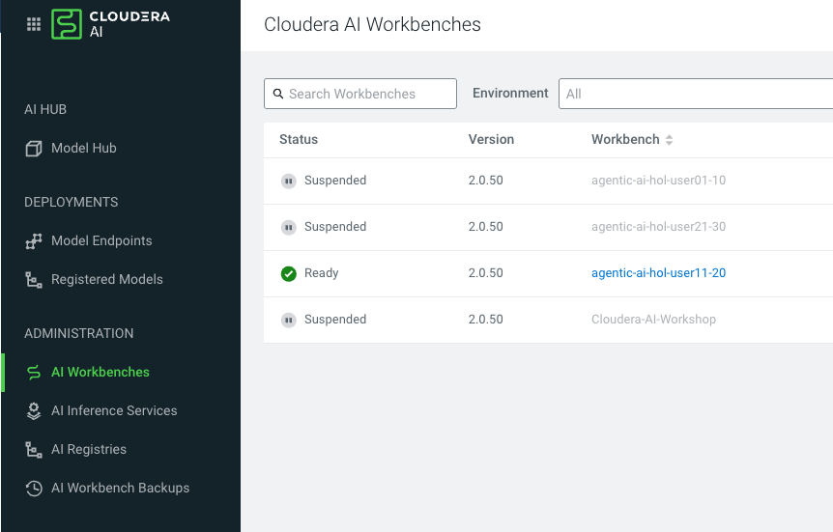

1. Go to “**Projects**” on the left side panel > Select “**Public Projects**” from the dropdown.

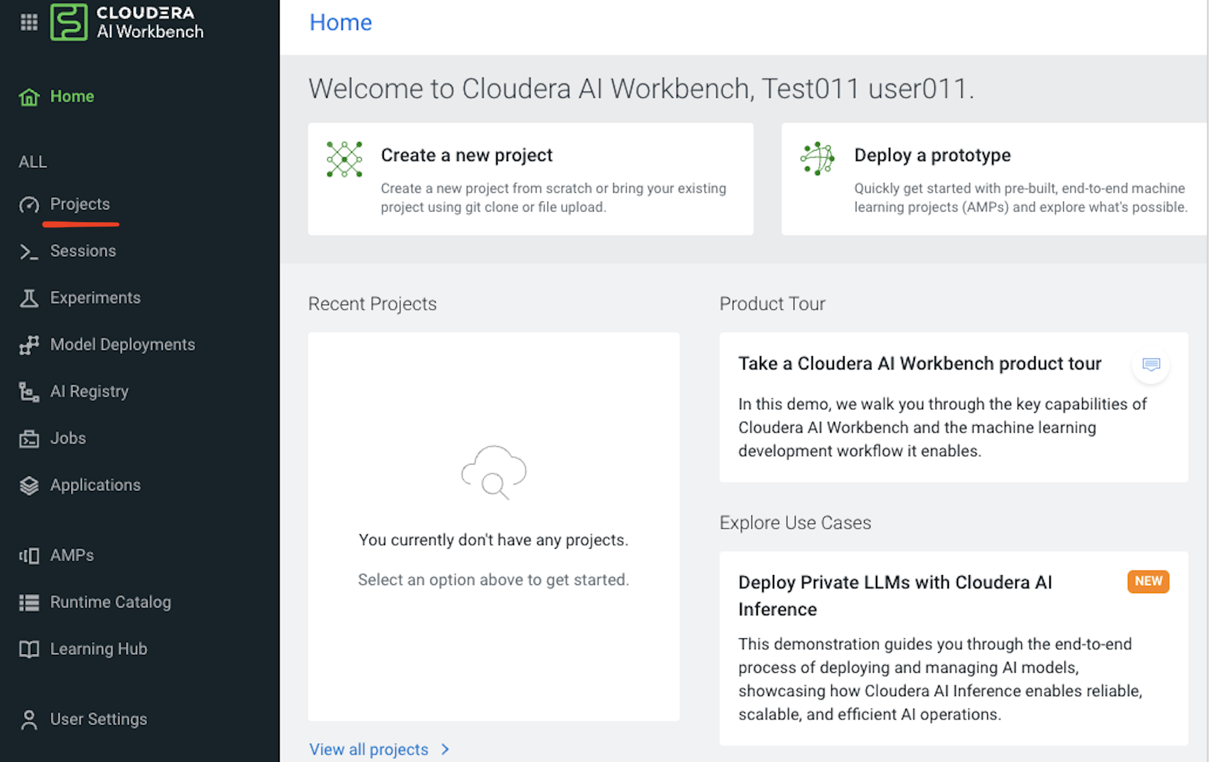

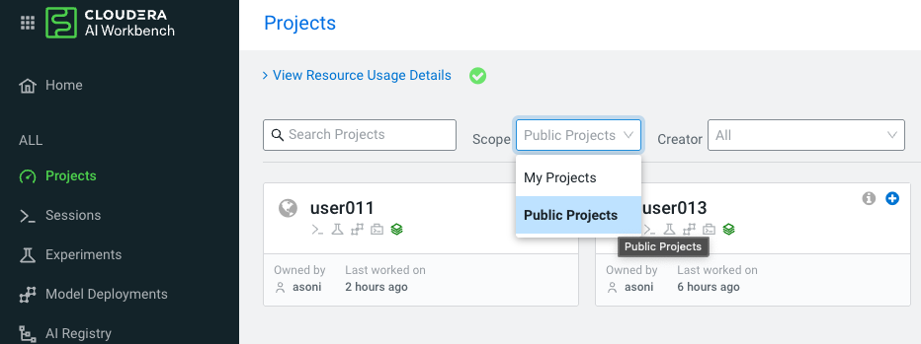

1. **Click** on the **publicly available** project named **HOL_Agent_Studio**

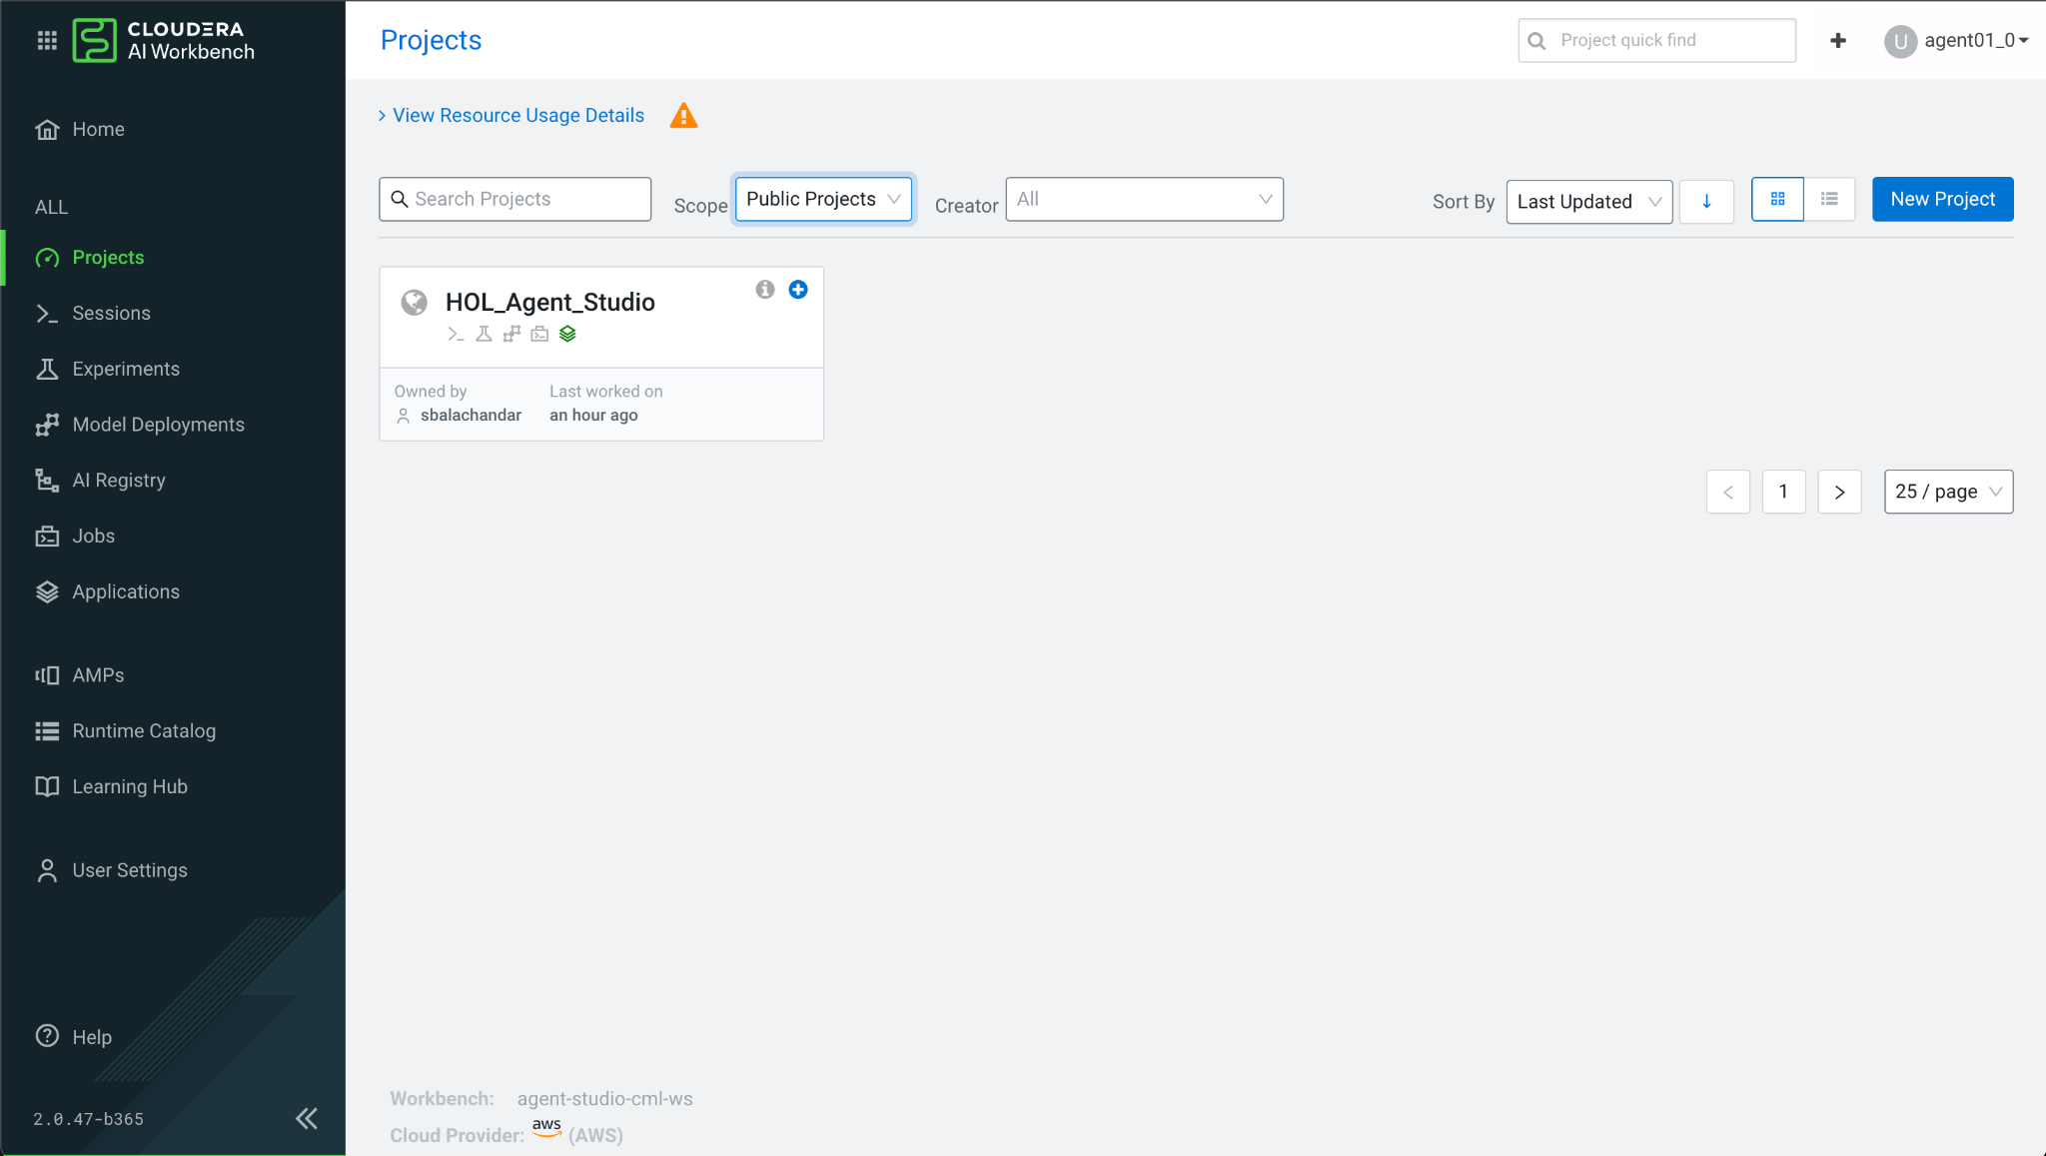

1. Click on **AI Studios > Agent Studio  
   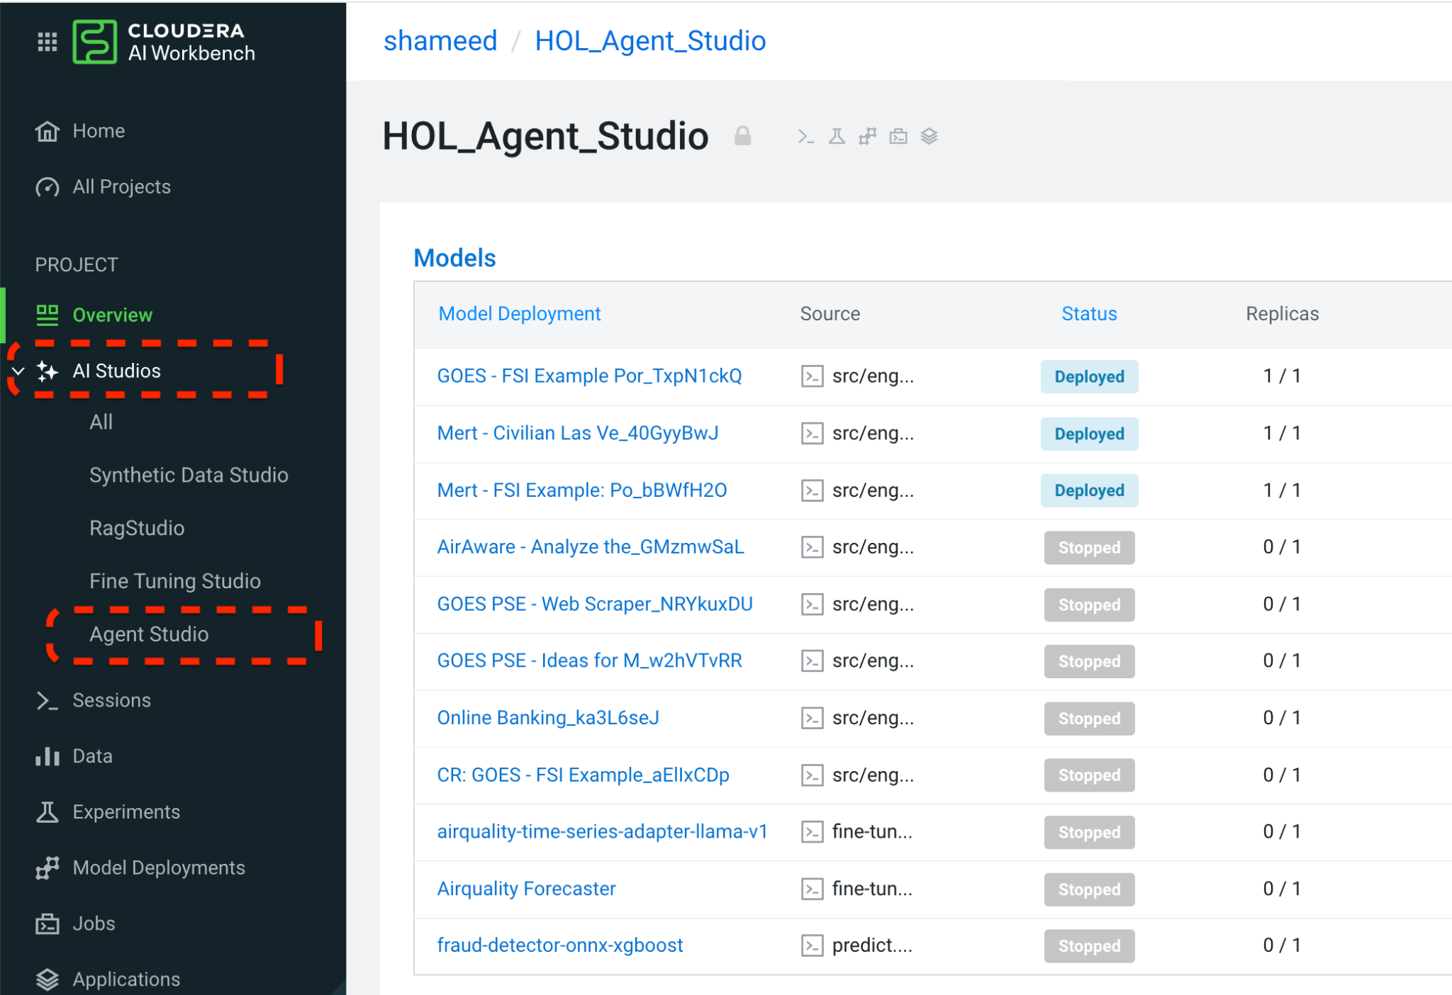**

**Step 2: Understand the Agent Studio Environment**

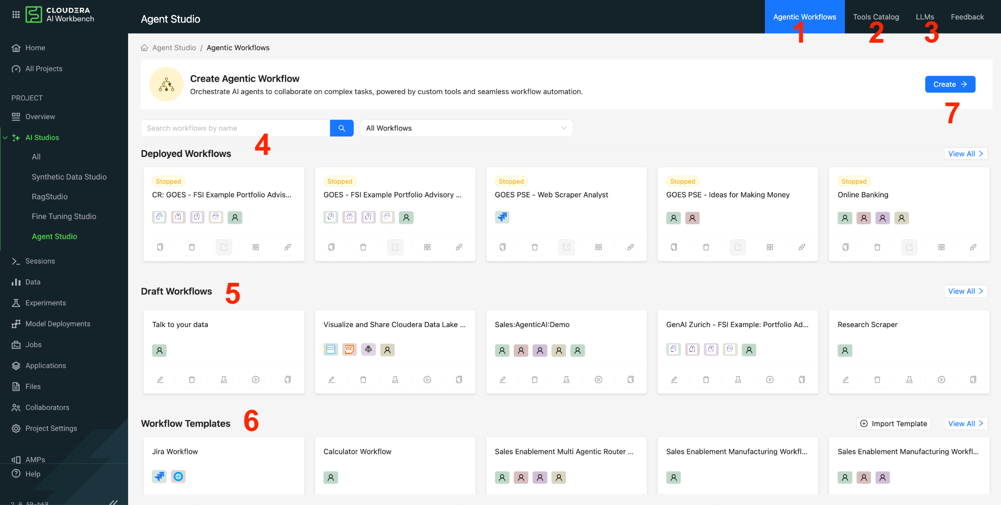

1. **Agentic Workflows:** Dashboard with End-to-End Agentic Workflows & Use Cases Development and Deployment.
2. **Tools Catalog:** Build custom Python tools to enhance your AI agents capabilities and supercharge your workflows.
3. **LLMs:** Hybrid Muti LLM Model Registry to Register language models which will be used to build agents and workflows.
4. **Deployed Workflows:** Single Pane of Glass to All Production Workflow and Use Cases.
5. **Draft Workflows:** Management and Collaboration all the Development Workflows.
6. **Workflow Templates:** Workflows Catalog to share and re-use the workflows.
7. **Create:** Build your Agentic Workflow from scratch

**Step 3: Let’s create the workflow**

**Here is how your workflow would look like at the end**

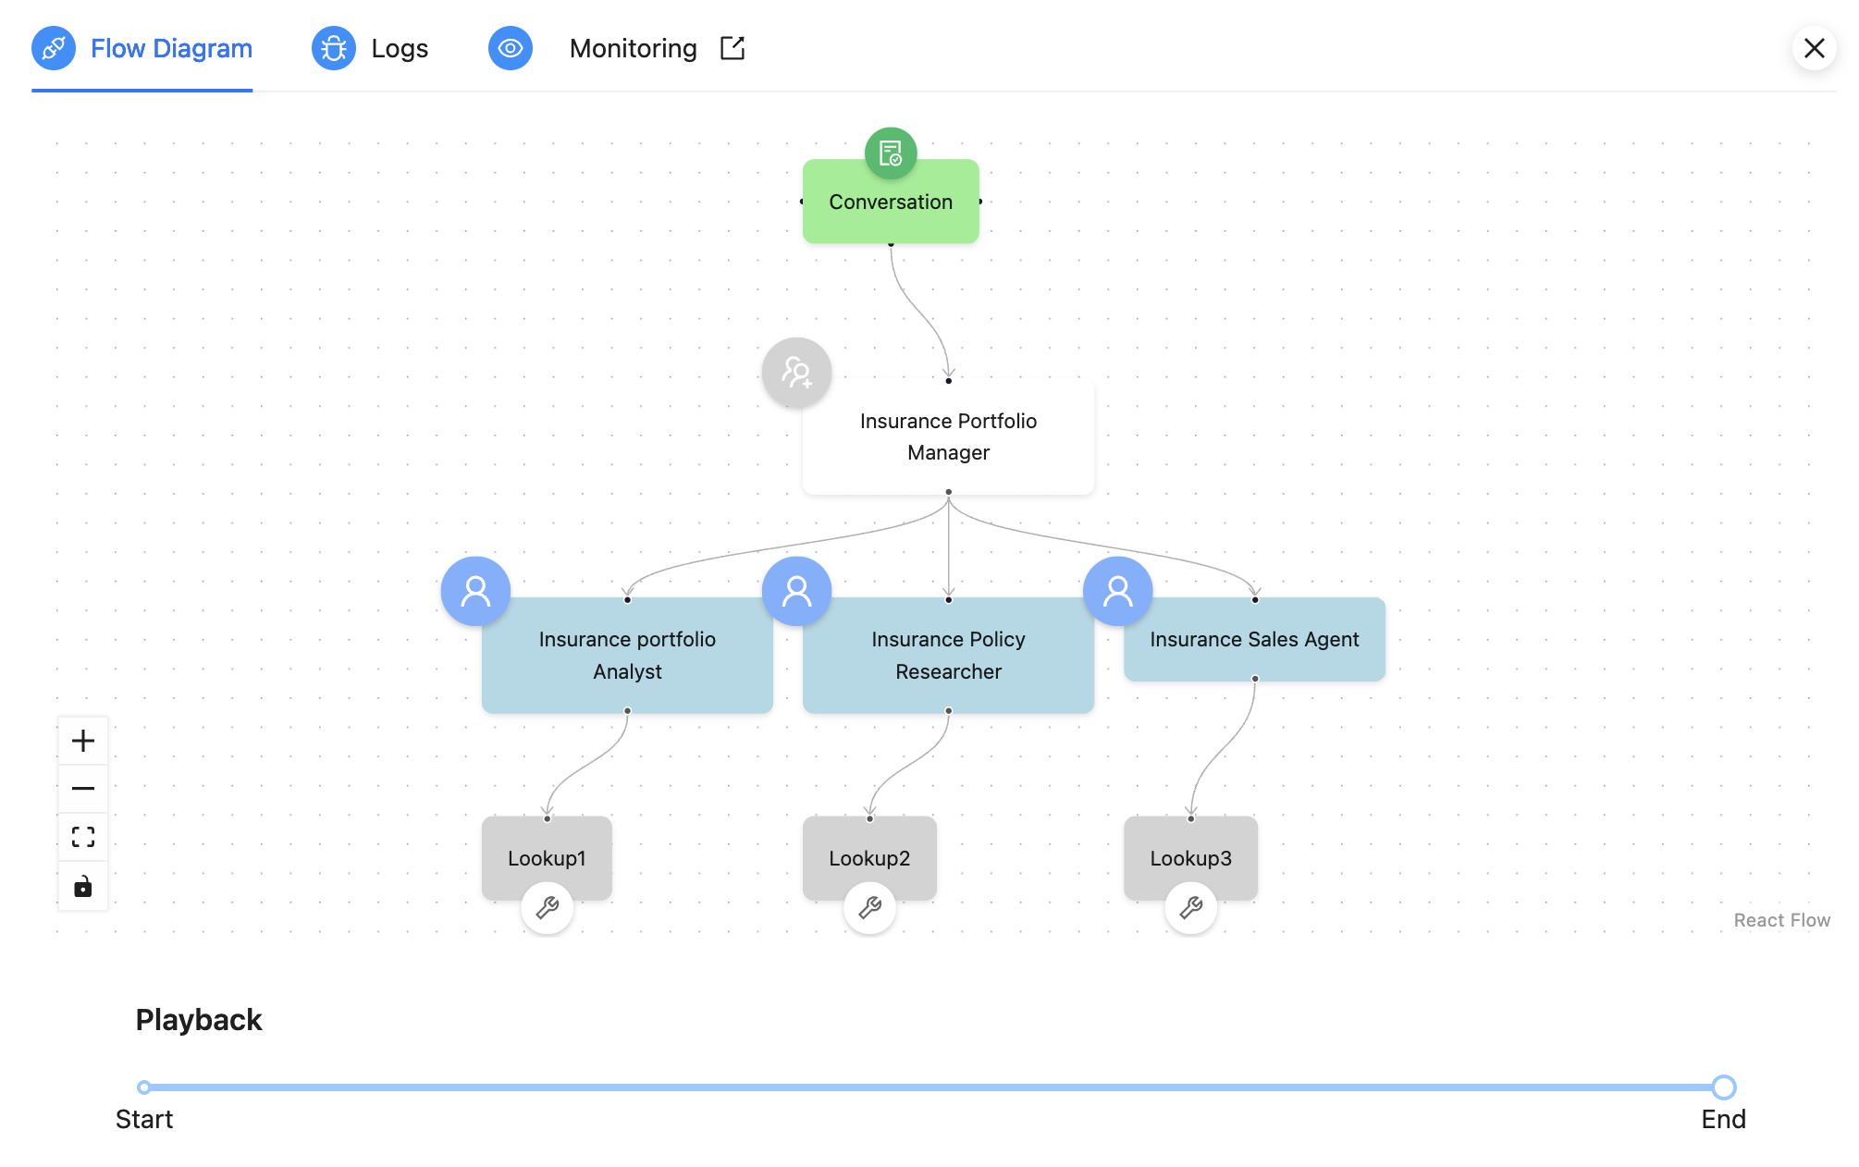

1. **Create > Insurance Workflow:** 
   1. Select Create to get started
   2. Provide the workflow name as your username for example ‘user001’ and create agent

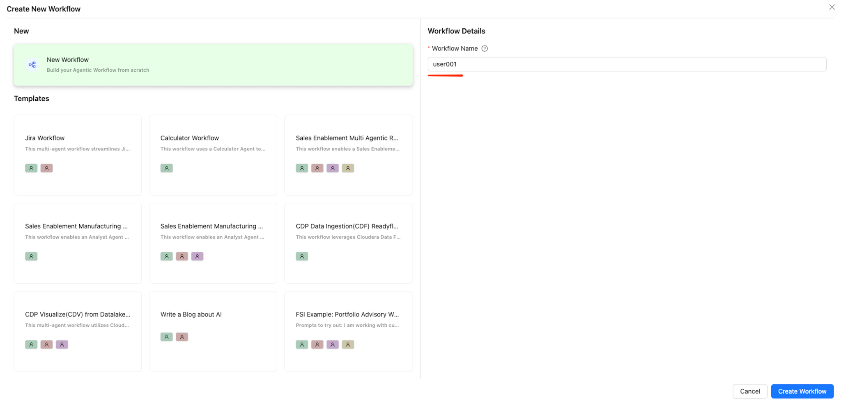

* 1. **Is Conversational: ON**
  2. **Manager Agent: ON**
  3. **Default Manager (click on configure custom manager):** 
     + **Name:** Insurance Portfolio Manager
     + **Role**: Insurance Portfolio Manager
     + **Backstory**: You are a Sr. manager capable of delegating tasks related to portfolio management and optimisation. One task is done by one agent only. Do not send one request to more than one agent.
     + **Goal**: Delegate the user request properly and forward relevant execution information to the user.

One task is done by one agent only. Do not send one request to multiple agents.

Send customer-related lookups to Insurance portfolio Analyst

Send research or find external policies to Insurance Policy Researcher

Send recommend and do upselling to Insurance Sales Agent

* + - **LLM** **model**: Default

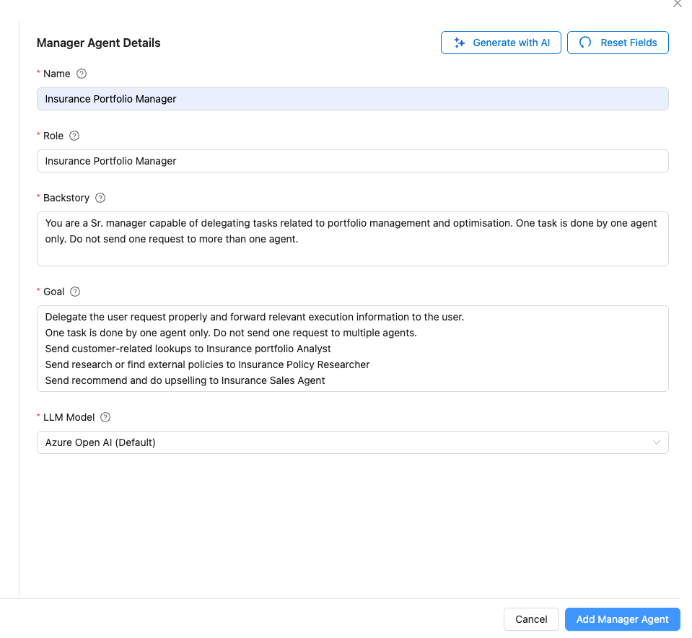

**Note:** There is an option of Generate with AI. We won’t be using this option today, but if you are creating another Manager Agent this could help!

1. **Create Three Agents: (click on create or edit agents)**

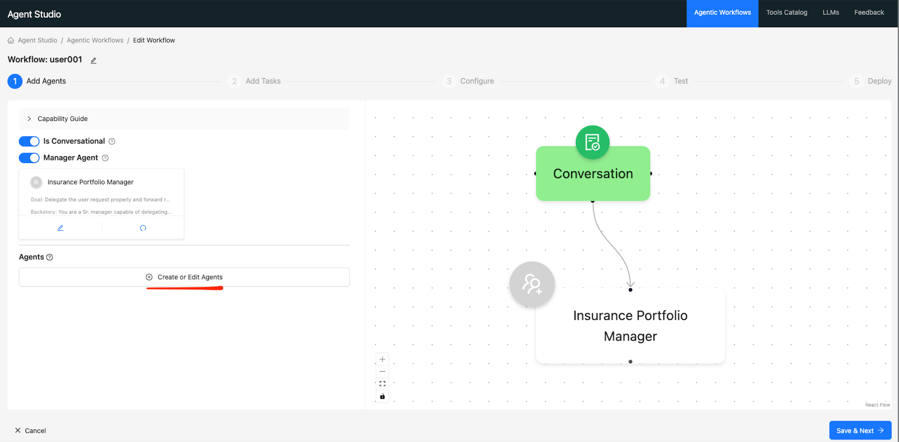

1. **Agent 1 : Insurance portfolio Analyst**
   * + Click on Create or Edit Agent (as per above screen capture)
     + **Name:** Insurance portfolio agent
     + **Role:** Insurance portfolio Analyst
     + **Backstory**: You are an experienced portfolio analyst who excels at understanding customer needs and current holdings.

You are able to fetch their current holdings and investment profile. do not hallucinate and provide the details retrieved from hive DB

* + - **Goal**: Fetch any requested customer portfolio or profile data. Do not hallucinate and provide the details fetched from hive DB
    - **LLM** **model**: Default

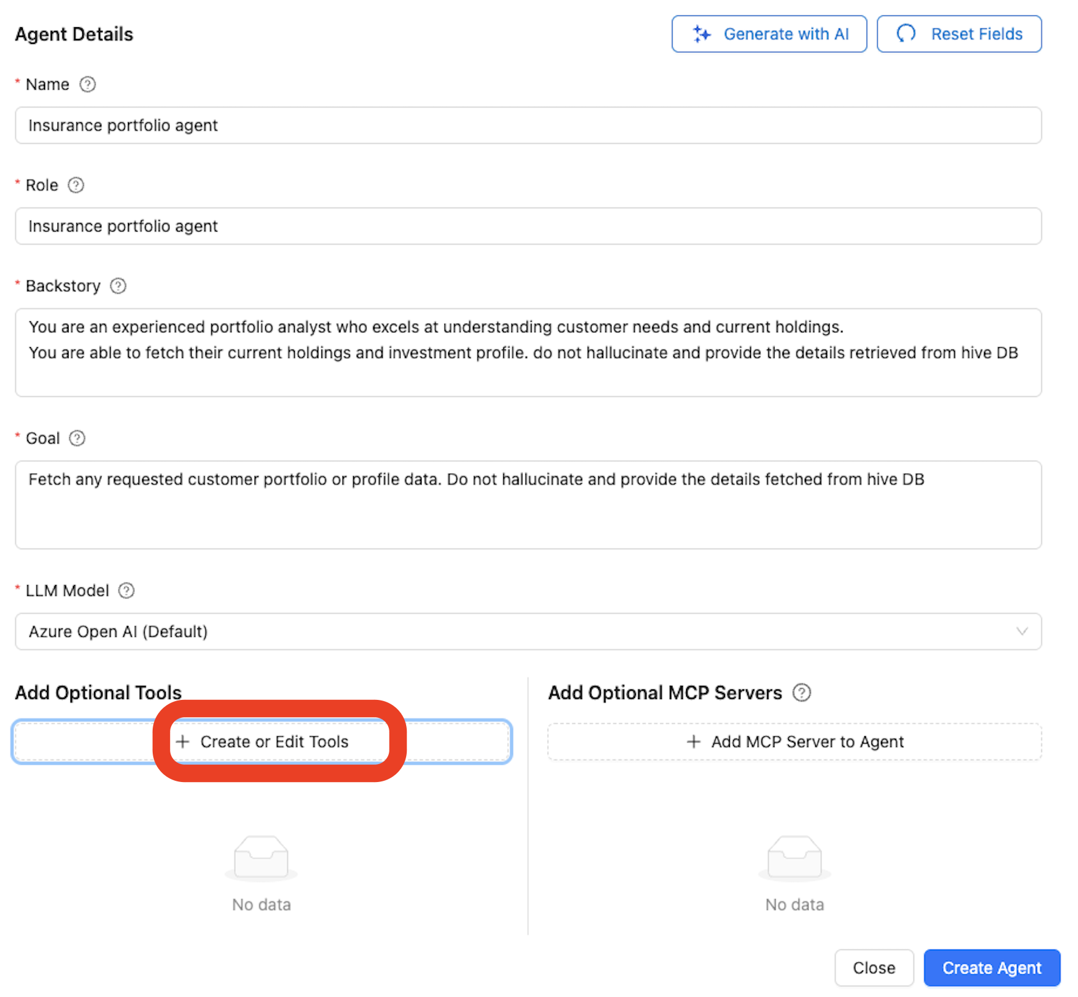

* + - Click on Create or Edit Tools (as per above screen capture)
    - Search for Hive Tool under Create Tool From Template

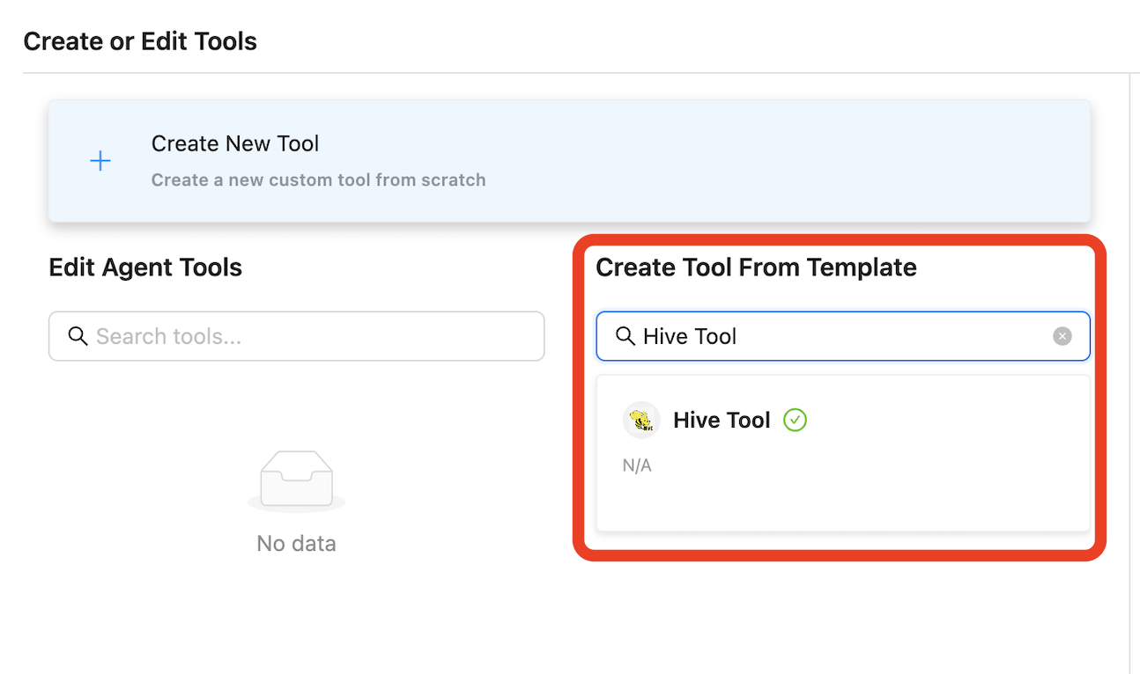

* + - Select Hive Tool and click Create Tool from Template
    - Click on Save Tool followed by clicking on Close and Save Agent and Close

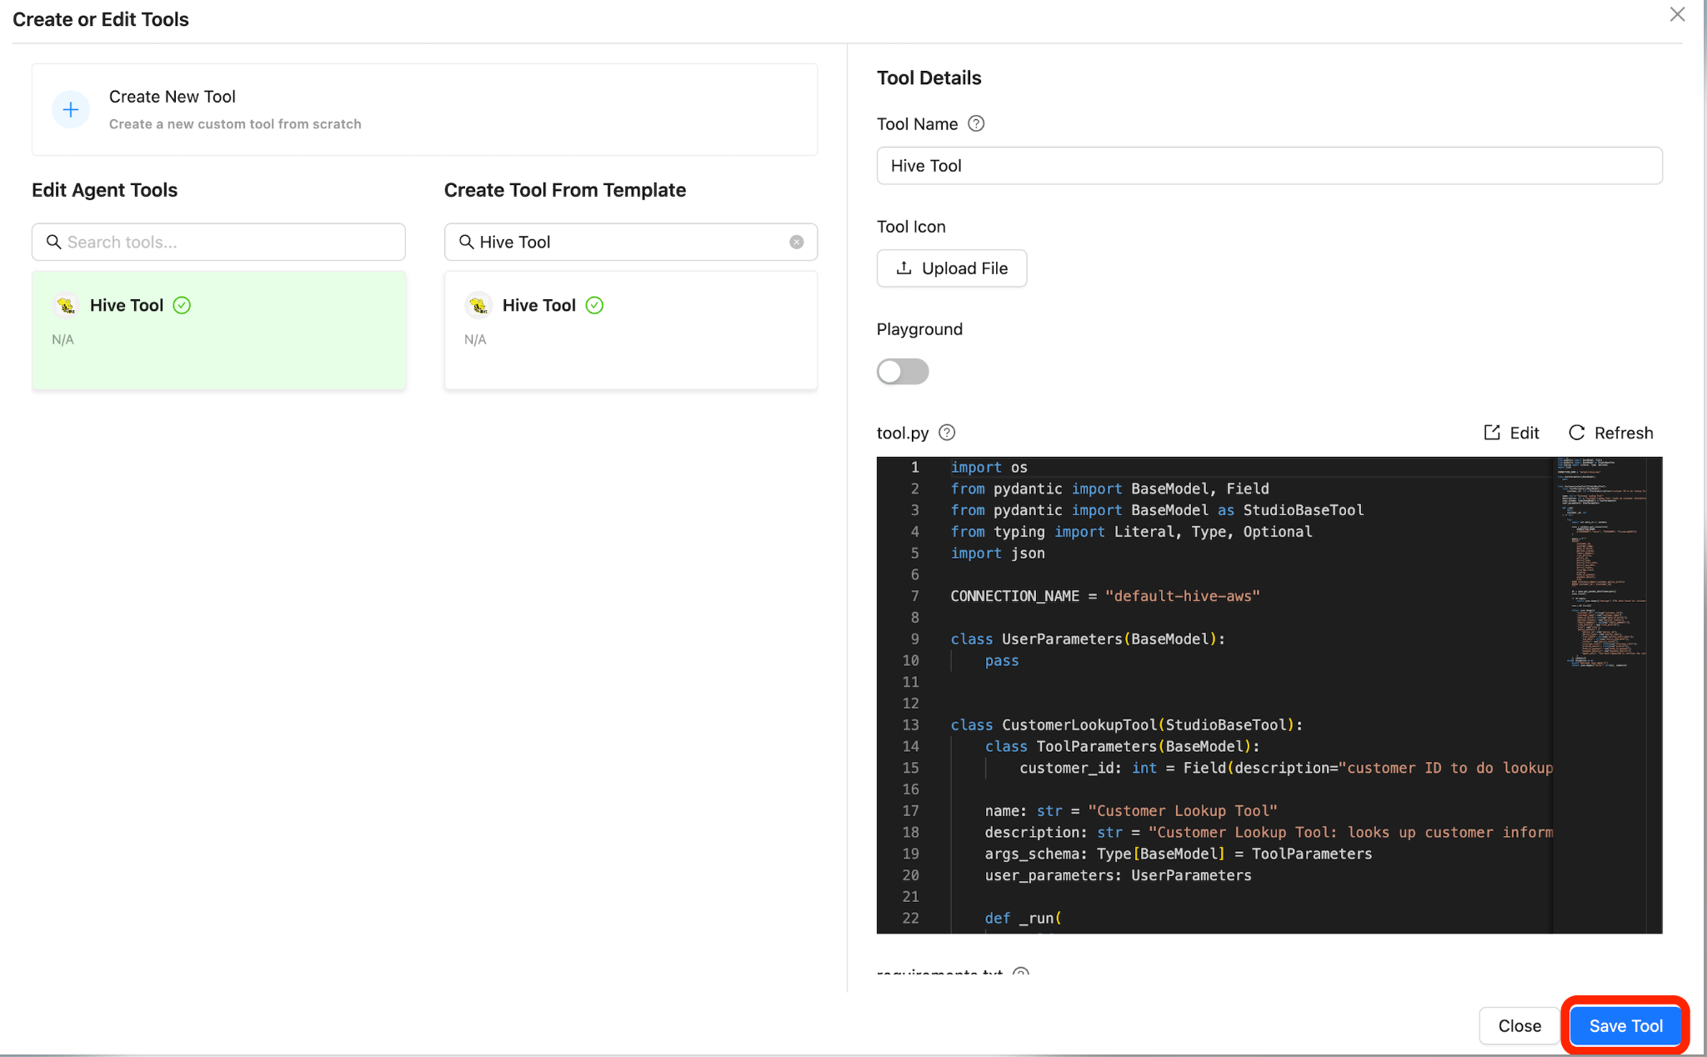

* + - Here is how your canvas should look and let’s proceed to add the next agent.

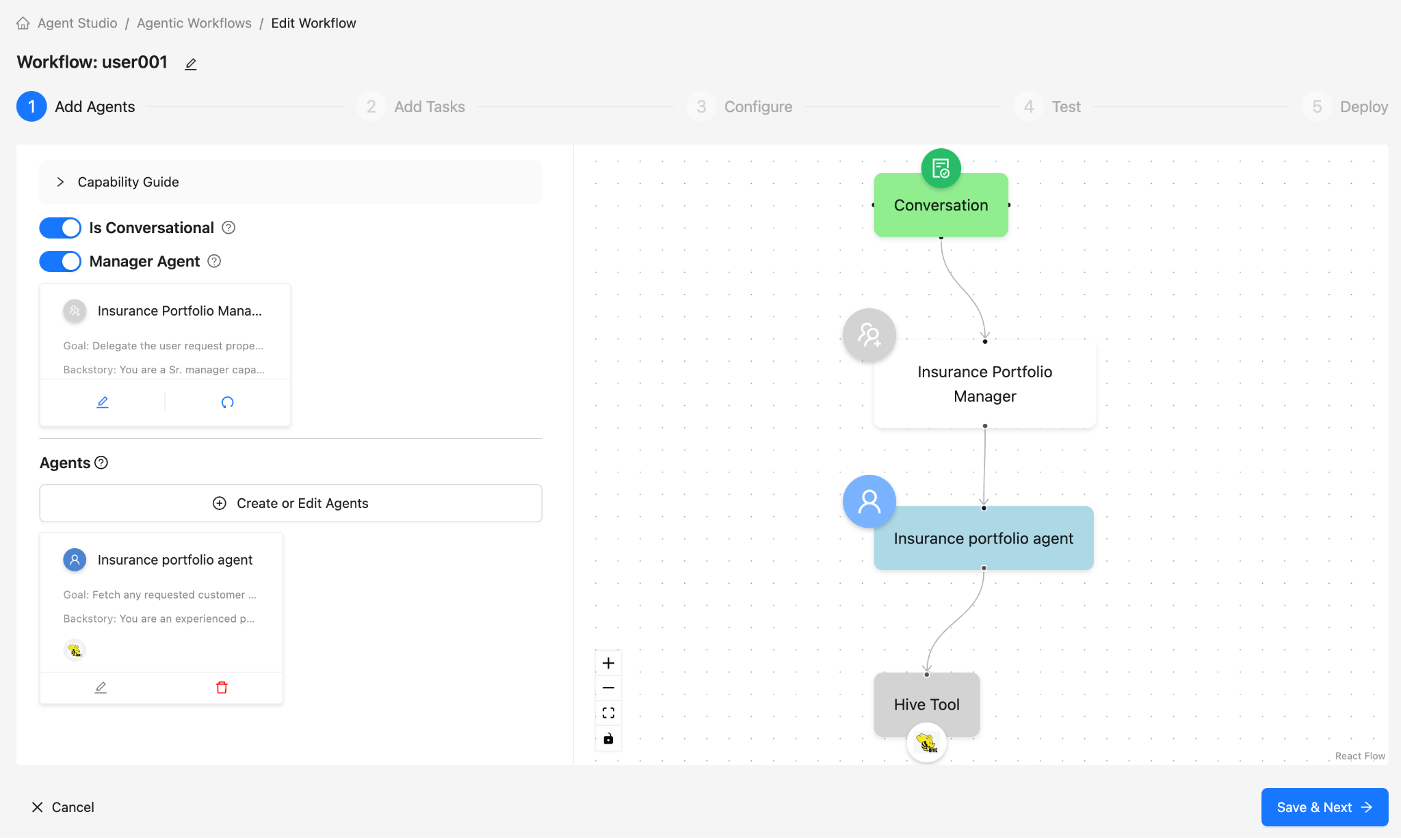

1. **Agent 2: Insurance Policy Researcher**

* Click on Create or Edit Agent (as we did while creating agent 1)
* **Name**: Insurance Policy Researcher
* **Role**: Insurance Policy Researcher
* **Backstory**: This agent is designed to perform research on all available insurance policies from Star Health via serper_api_key. It should access brochures or policy documentation from Star Health's website and use it to identify additional policies, benefits, and coverage options that might be suitable for the customer.
* **Goal**: Responsible to analyse available policy documents and brochures.
* **LLM** **model**: Default
* Select Create or Edit Tools

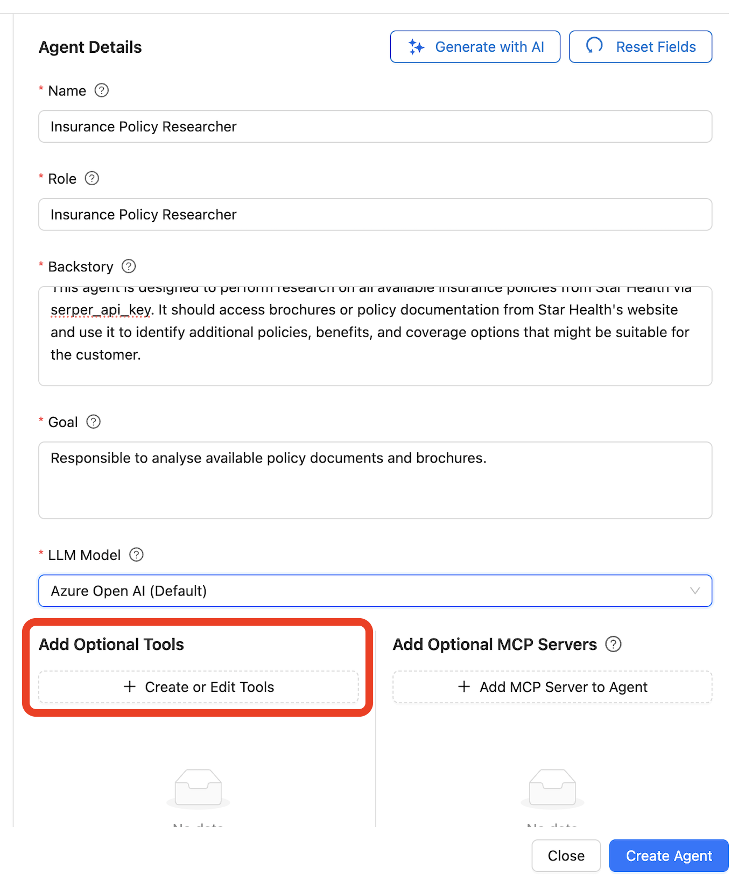

* Search for Serper Tool under Create Tool From Template

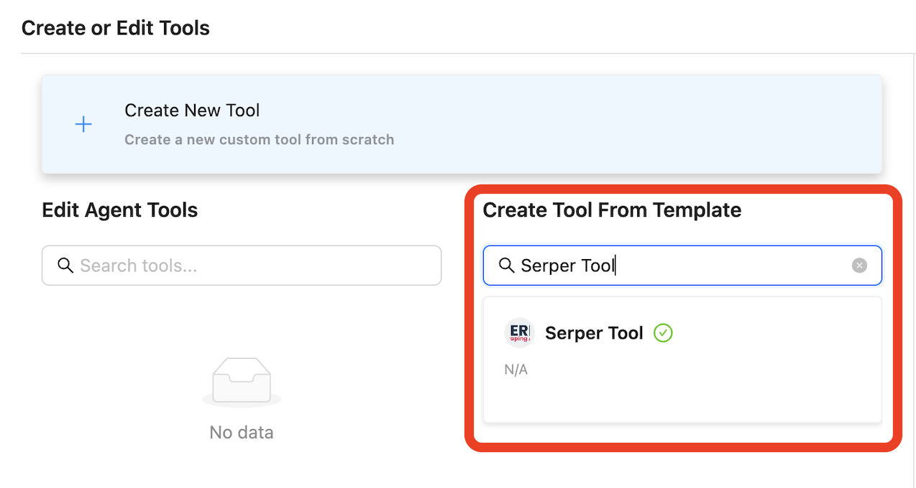

* Select Serper Tool and click Create Tool from Template
* Click on Save Tool followed by clicking on Close and Save Agent and Close
* Here is how your canvas should look and let’s proceed to add the next agent.

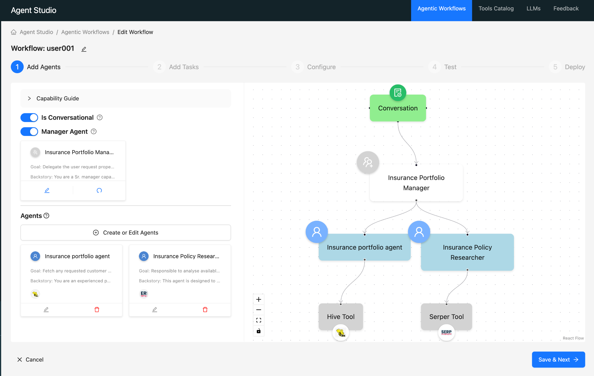

1. **Agent 3: Insurance Sales Agent**
   * + Click on Create or Edit Agent (as we did while creating agent 1)
     + **Name**: Insurance Sales Agent
     + **Role**: Insurance Sales Agent
     + **Backstory**: To recommend personalised policy options to the customer. It should be able to propose new policies or suggest upgrades based on the customer's existing policies, risk profile, and coverage needs.
     + **Goal**: Recommend a better insurance policy for the customer based on the current Star Health policy
     + **LLM** **Model**: default
     + Select Create or Edit Tools

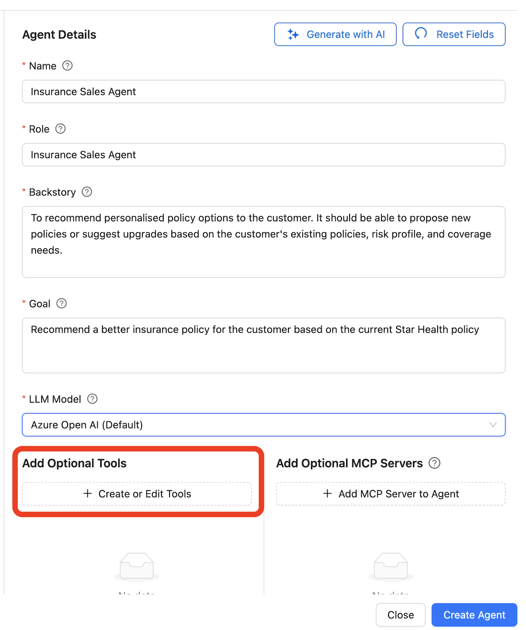

* + - Search for Python Tool under Create Tool From Template

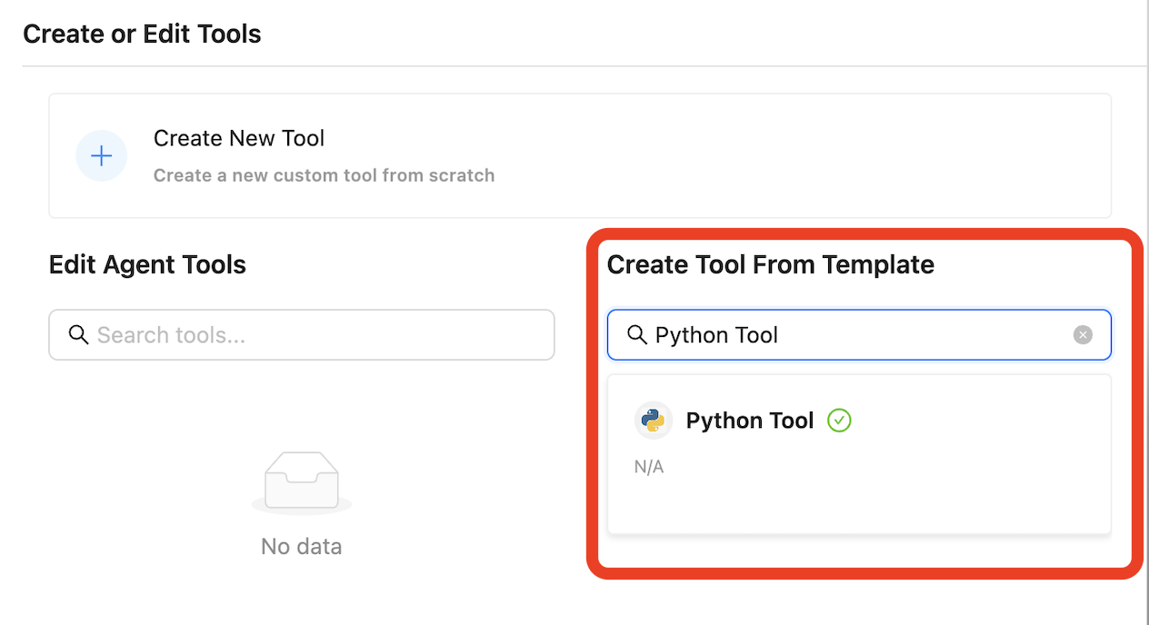

* + - Select Python Tool and click Create Tool from Template
    - Click on Save Tool followed by clicking on Close -> Save Agent -> Create Agent -> Close
    - Here is how your canvas should look and let’s proceed to add the next agent.

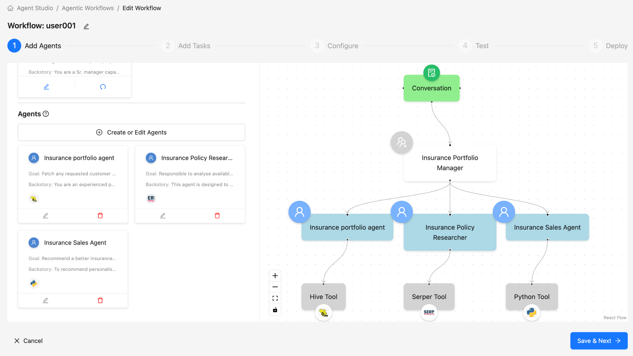

**Step 4: Let’s run the workflow**

* **Click on Save and Next**

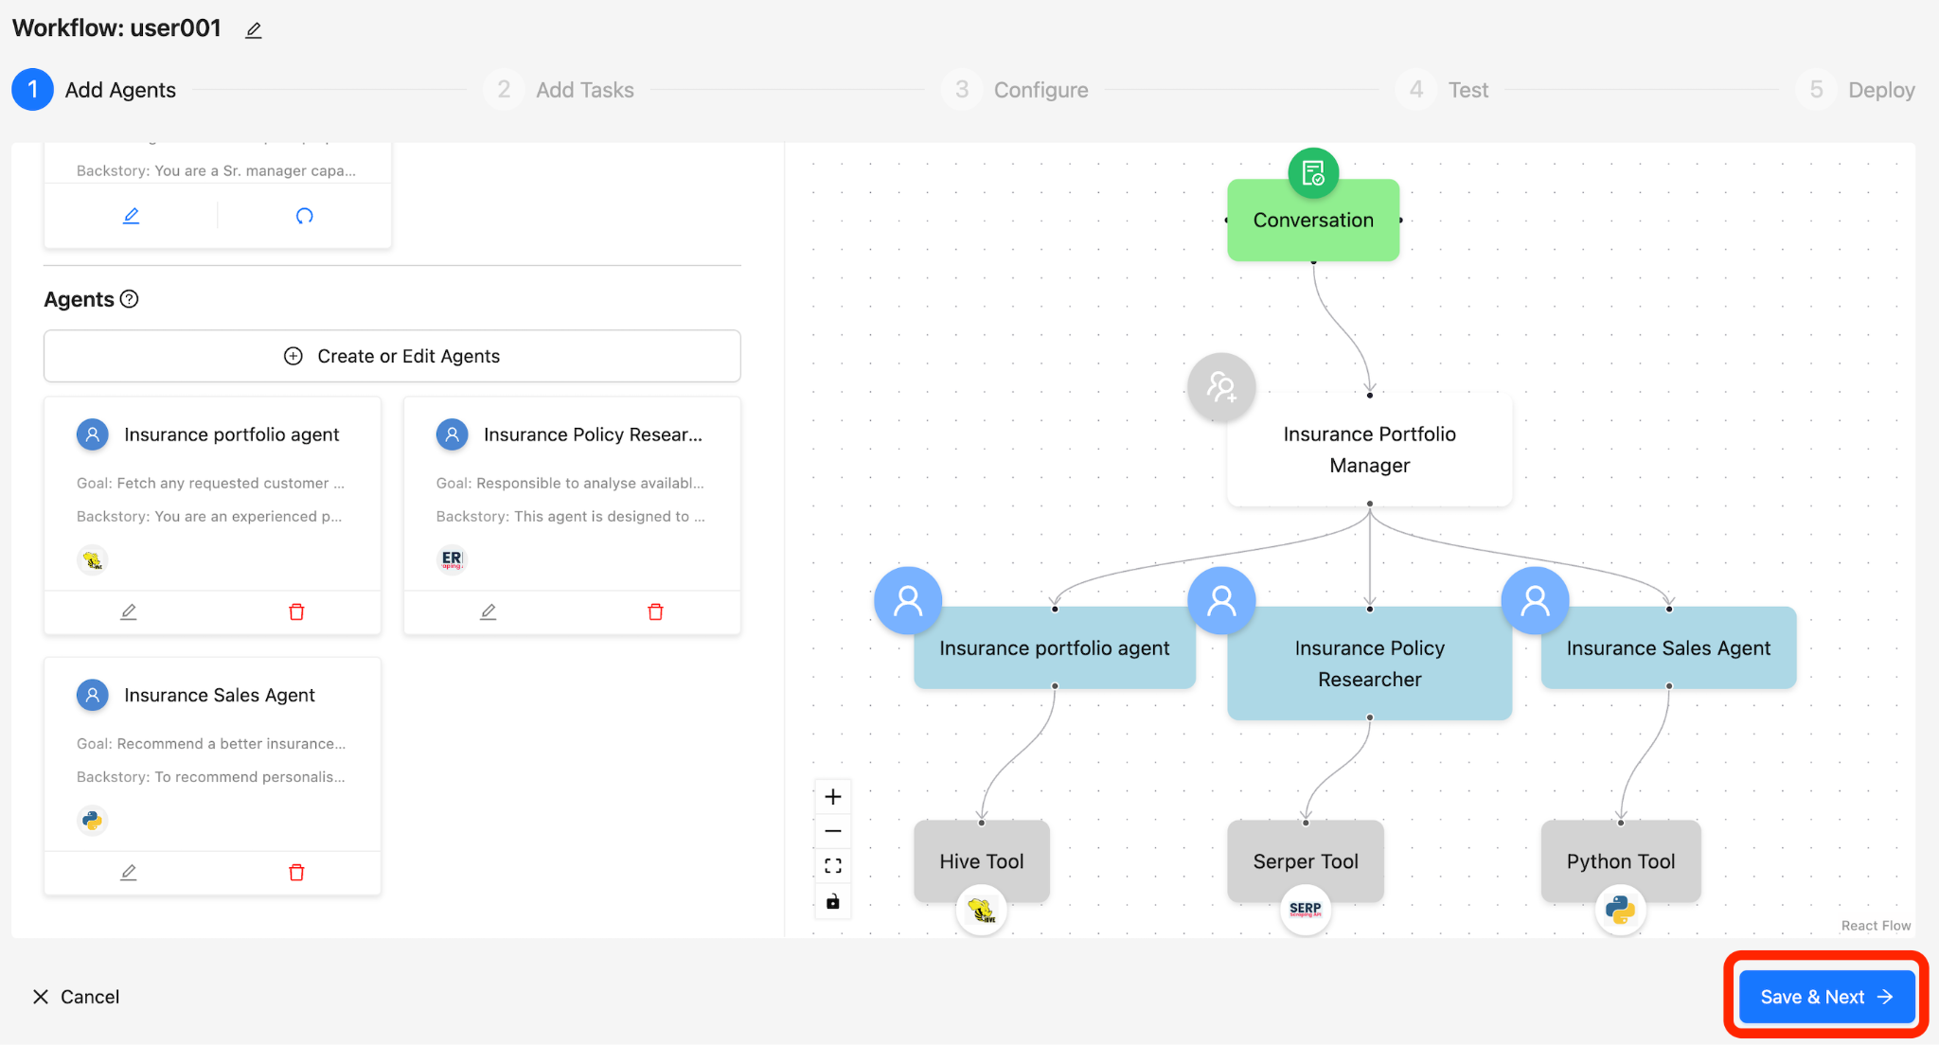

* **Review and Click on Save and Next**

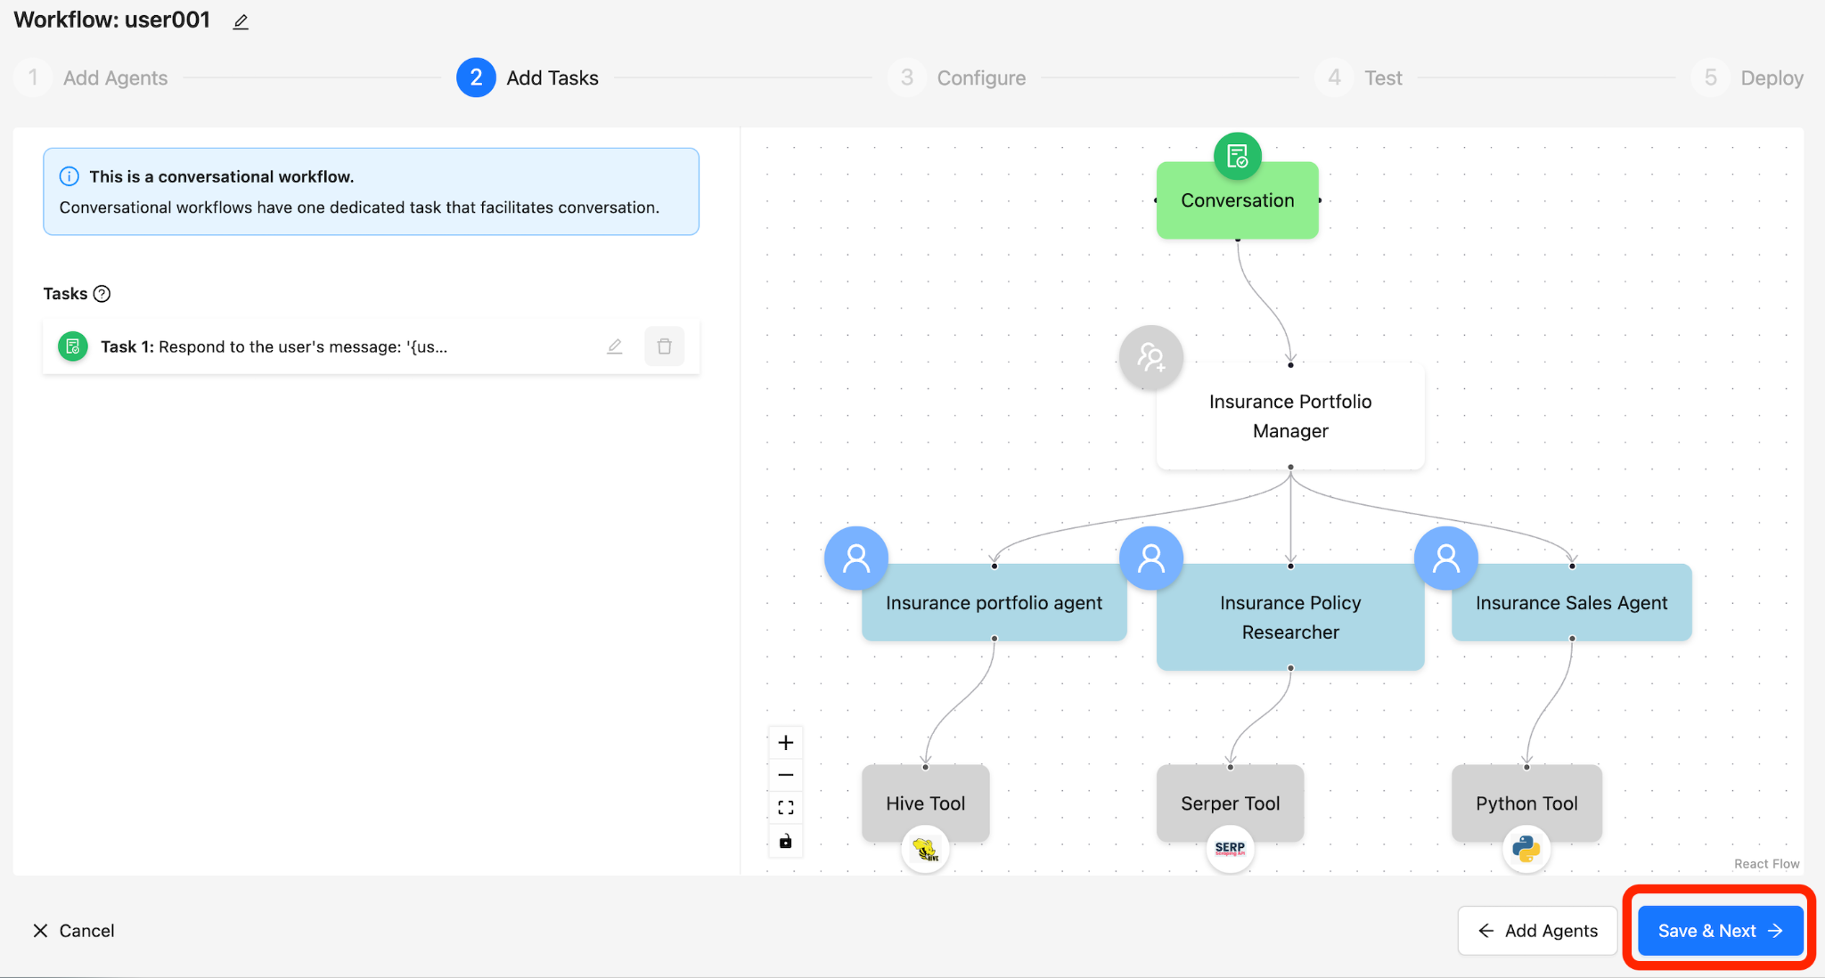

* **Set the Temperature to 0.1 and Review and Click on Save and Next**

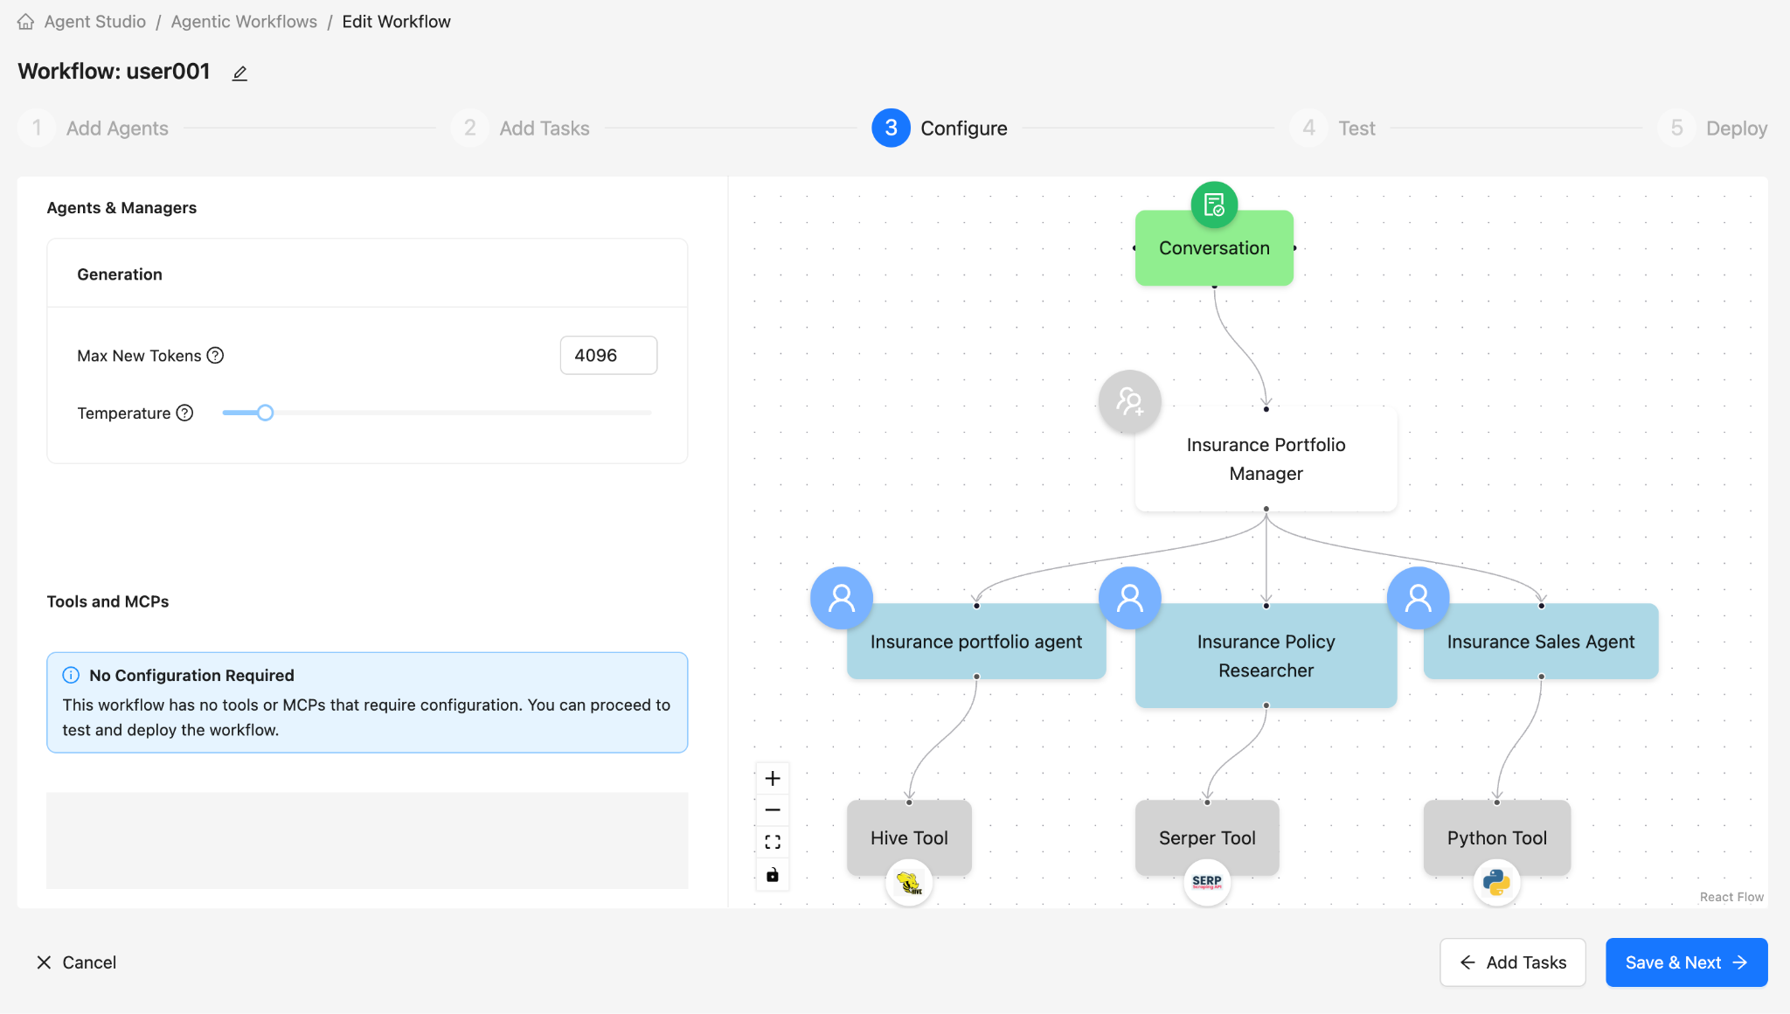

* **It’s time to play with the agent**

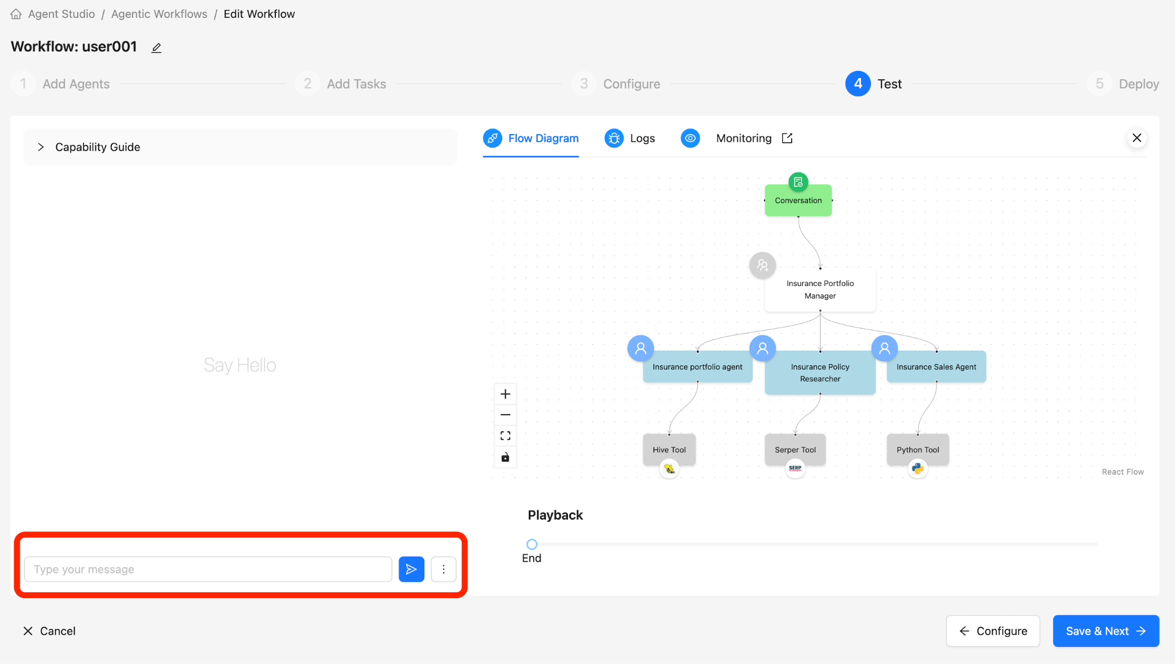

* **TEST the workflow with the following queries:**
  + **Prompt 1**: “Fetch customer details 600001” (Also could do 600001 -> 6000030)
  + **Prompt 2**: “Research other policy documents and brochures on star health”
  + **Prompt 3**: “Recommend a better insurance policy for **<customer_name>** customer id <**60000X>** based on the current Star Health policy”
* **You could deploy this into the Production workflow. But for now we will keep it simple and continue to run in the testing phase**

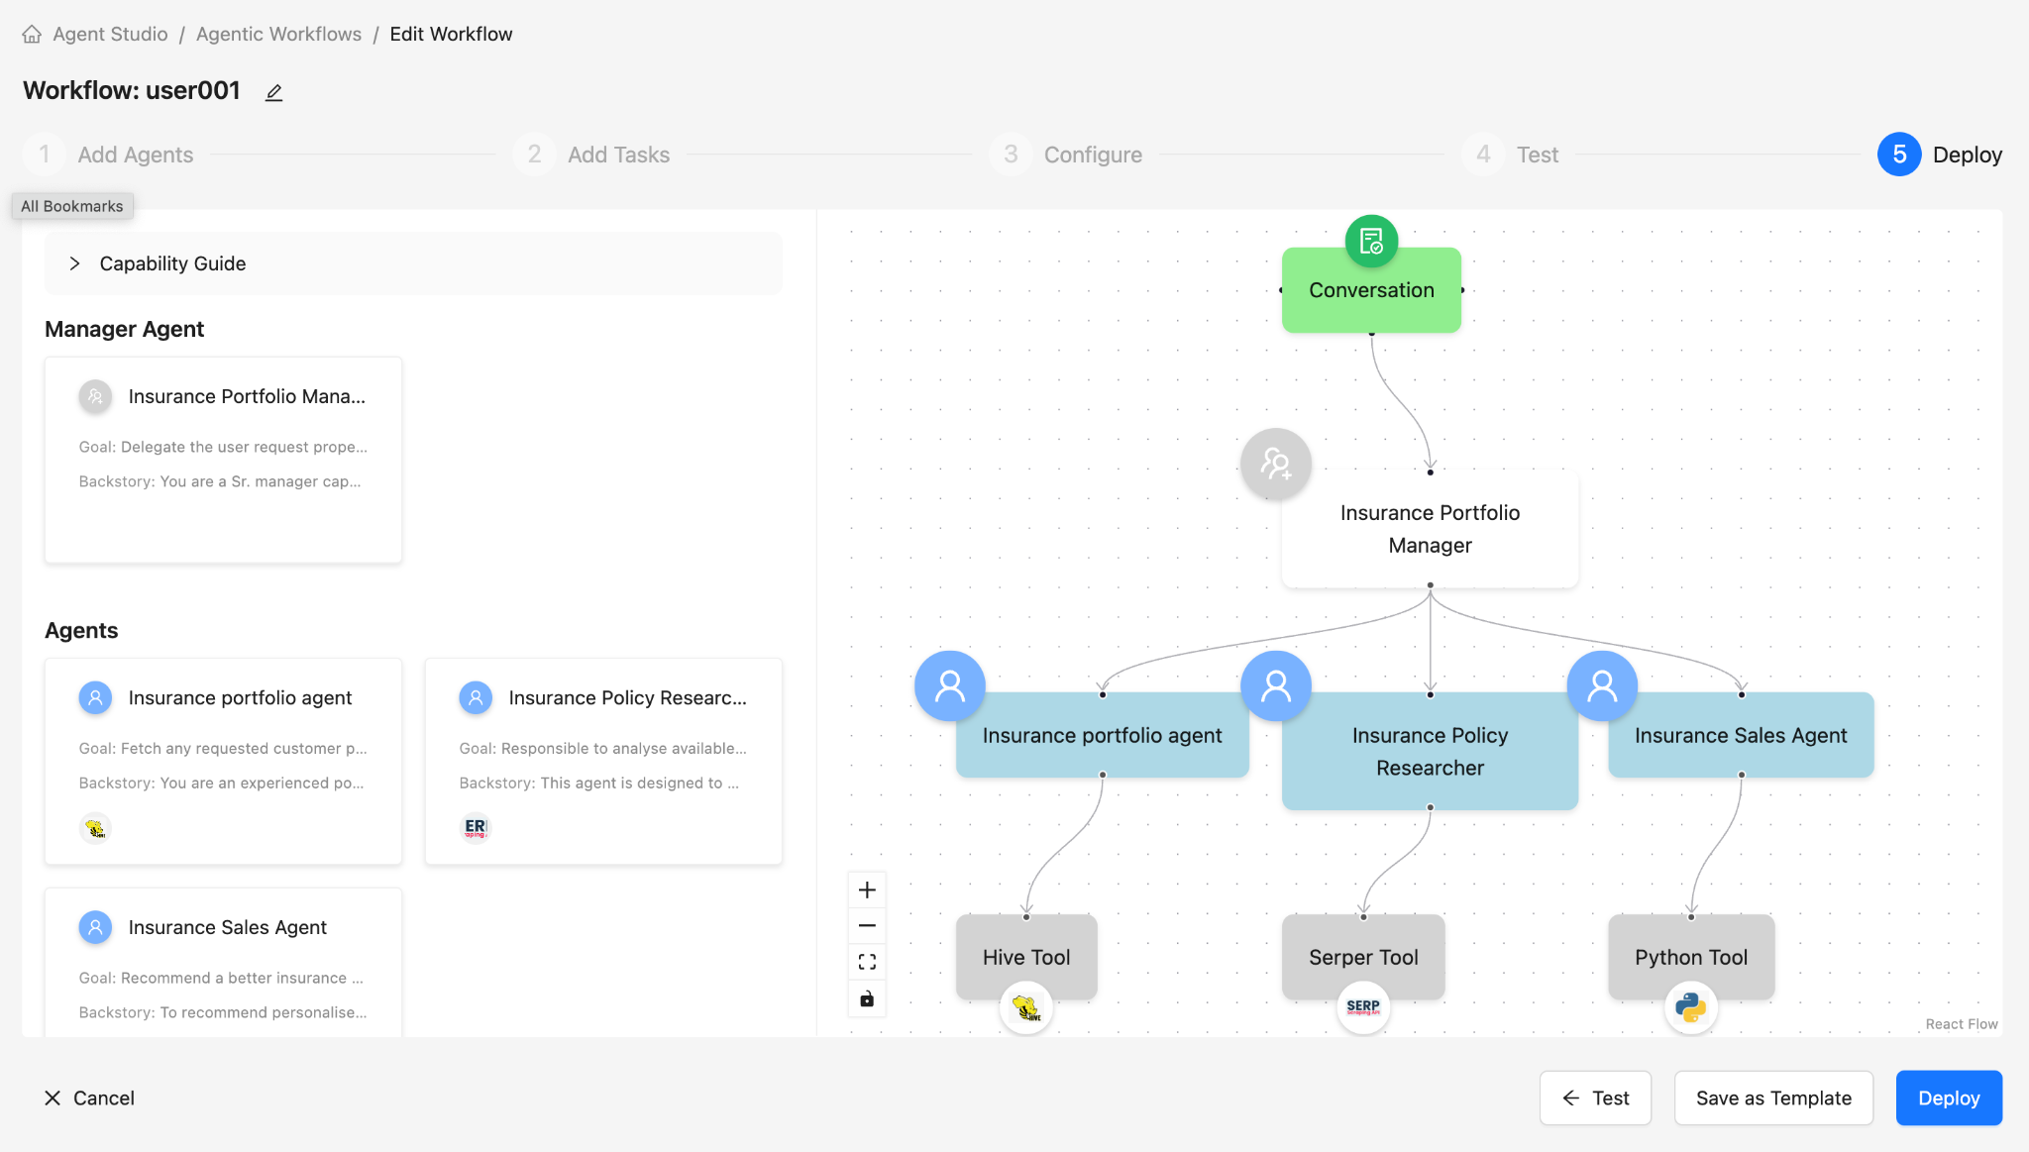

* **You are done with the Lab, you can continue testing or you can close the browser window**

